STEPTEMBER…  STEPPING FOR STROKE | 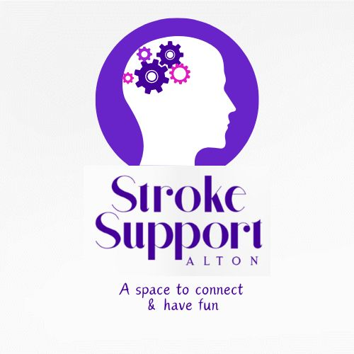
September has become Steptember! My challenge is to commit to ________ steps each day through the month (30 days).
Please sponsor me per step. Raising funds for Alton Stroke Support Group, Kings Arms Youth Project and Mudhouse Children’s Foundation (Tanzania)
Name | Address/email | Phone | Amount per step
Name | Address/email | Phone | Amount per step
Please decide how you wish to split your money raised between the three projects and make this clear on paying in. Either pay in cash at Steptember Gathering in Alton Park on 30th September or by bank transfer to Alton Stroke Support Group Metro Bank a/c 53599494 s/c 23 05 80
Good luck with Steptember!
Alton Stroke Support Group tel:- 07340739251 Email: admin@altonstrokesupportgroup.org.uk
Kings Arms Charity No. 1087176 Mud House Children’s Foundation Charity No. 1160089

